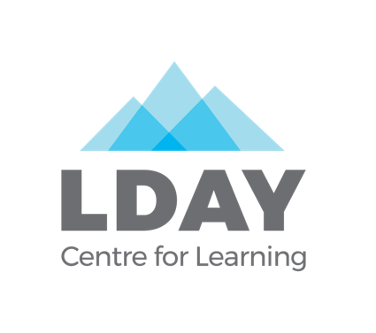
For office use: Date received: ___________
Week: __________

SUMMER CAMP RAVEN 2024
Registrations will be accepted as they are received.
We are happy to assist you with this form: CampRaven@LDAYukon.com, 668-5167

Camper Details:
Camper’s Name: Sex:
Birth Date: / / Age:
dd mm yyyy
Home Address:
Parent/Guardian Details:
Full Name:
Home Address:
Work Address:
Home #: 3 52121 Cell #: 3 521 21 Work #: 3352121
Best method of contact during the day: □ home □ cell □ work
Email:
Other/Emergency Contact:
Full Name:
Home Address:
Work Address:
Home #: (86 7) 3 35-2121 Cell #: (86 7) 33 5-2121 Work #: (86 7) 335-212
Best Method of Contact During the Day: □ home □ cell □ work
Camp Raven details:

Week One: June 24 - 28 Week Two: July 8 - 12
ages seven to nine ages nine to eleven

Week Three: August 5 – 9
ages seven to nine

All three weeks of camp will run Monday to Friday, 9:00am – 3:30pm. Campers are required to bring lunches, snacks, and water for all sessions.

Campers should have clothing appropriate to the weather including proper footwear, snow pants, warm jacket, mittens, hats and winter boots and an extra change of clothes as we may be outside for extended periods of time.

Cost:

The total cost for Summer Camp is $250 (5 days x $50/day). Please connect with us if this would be a barrier for your child’s participation.

Does your child receive financial support from YG Disability Services?
□ Yes □ No

Health Information:

Health Care #:
Family Physician: Family Physician Phone #:
Does your child have any medical concerns? (Including asthma, injuries, or any allergies to food, animals, plants, medication, etc.)
L
L
Does your child take any medication? If so, what medication? How is it taken? How often?

Helpful Camper Information:
L
What are your child’s strengths? What motivates them?
L
What are your child’s challenges? What is difficult for them?

Can your child swim? If so, at what level?

Does your child have any fears? (dogs, heights, water, darkness)?

Does your child regularly have one-on-one EA support or an Inclusion Worker for activities outside of school?
Is there anything else that you feel we should know about your child that we have not asked?
L

Release Forms (3) for Camper: _________________________________________ (camper’s name)

- ASSUMPTION OF RISK, RESPONSIBILITY AND RELEASE FROM LIABILITY
I hereby acknowledge that the activities my minor child is participating in, both on and off the premises used by Learning Disabilities Association of Yukon (herein after called LDAY) with regard to all LDAY day camp events, involve risks and dangers inherent to day camp activities and events, including (but not limited to) travelling in motor vehicles, sports, swimming, working with crafts, cooking and hiking.
In consideration of LDAY permitting my minor child to use its facilities and day camp services and for other good and valuable consideration, I hereby release LDAY, its members, employees, agents, officers, directors, associates and volunteers from any liability arising out of or in connection with those risks and dangers as set out above, and otherwise, including transfer to and from activity sites.
I further accept and assume all risks of personal injury and death or loss or damage to property while my minor child is participating in the said activities and events, including without limitation, personal injury or death, or loss or damage arising from the acts or omissions, including negligence, on the part of LDAY, its members, employees, agents, officers, associates, directors and volunteers.
I acknowledge that I have read the contents of this document and understand that I am relinquishing any and all rights that I and my children and our respective heirs, executors and administrators might otherwise have against LDAY, its members, volunteers, employees, agents officers, directors and associates.
I further agree to indemnity and hold harmless LDAY, its members, volunteers, employees, agents, officers, directors, and associates from any and all claims, losses or damage arising from my minor child’s participation in the day camp, including property damage and personal injury caused to other persons by the deliberate act or negligence of my minor child.
I further acknowledge that I am nineteen years of age or older and that I accept the terms of the release as set out above.

- PHOTO RELEASE FORM
I give permission for images of my child captured during the Learning Disabilities Association of Yukon (LDAY) winter and summer camps through video, photo and digital camera to be used by LDAY for the sole purposes of promotional material and publications, including its website, fundraising or any other like purpose and further give my consent for said images to be shared with camp funders including Lotteries Yukon, United Way Yukon, City of Whitehorse and Yukon Foundation. I further understand that by signing this release, I waive any and all present and future compensation rights to the above stated material(s).

3. Health Declaration

I understand that if my child is presenting any cold or flu like symptoms, I will cancel all Camp Raven sessions until they are free of symptoms. Symptoms include: cough, fever and/or chills, difficulty breathing, any other cold or flu like symptoms.
Signature for all three release forms: Assumption of Risk, Responsibility and Release from Liability; Photo Release; Health Declaration:

Dated at the City of Whitehorse, in the Yukon, this _________ day of _________________, 2024.

Name of parent/guardian: ________________________________________________________
Signature of parent/guardian: ________________________________________________________

In the presence of: ________________________________________________________
witness

